This section is filled by the author
Authors must provide justification or section reference where applicable.
Authors Submission Checklist
All manuscripts must meet the following criteria to be processed into the peer-review stage. Failure to meet the following criteria may increase the processing time of the manuscript or even rejection.
Write OK if the authors have confirmed that the manuscript meets the criteria. If the author cannot fulfill these criteria, give a reason, and write in the checklist with highlighted text.

1 | Template and Layout | Authors Claim &  Comment | Editors  Comment
1.1 | Have used the latest CNAHPC template (latest update June, 2021) | √
1.2 | Introduction, Literature Review Methods, Result, Discussion, and Conclusion are written in a separate section. | √
1.3 | Not using Bullet / Numbering in the manuscript text. | √
1.4 | The length of the text is between 6 and 12 pages. | √
2 | Title and Authors Information
2.1 | The title is written briefly, describing the contents and contributions of the manuscript. The title also does not use abbreviations or acronyms except the standard ones. The title consists of a maximum of 14 words. | √
2.2 | All authors have been written in the manuscript and also in the OJS system. One of the authors who corresponded through the OJS system was determined as the correspondence authors. | √
2.3 | All authors must include e-mails in the manuscript and the OJS system. | √
2.4 | Affiliation information is written in 1 line in the text, at least showing the name of the institution and country. Full Address information should be written in 1 line bellow affiliation information. | √
2.5 | The title of the manuscript is written using 'Capitalize Each Word', except conjunctions using lowercase. | √
2.6 | The place and time of research do not need to be included in the title unless the research is specific to a particular time and place. | √
3 | Abstracts and Keywords
3.1 | Abstract consists of 200 to a maximum of 250 words. | √
3.2 | Abstracts are arranged in a structured manner. Consisting of Background, Objective, Methods, Results, and Conclusion | √
3.3 | The number of keywords minimal 5 words | √
3.4 | All keywords must be written in the abstract. | √
3.5 | Keywords are arranged in alphabetical order. | √
3.6 | A combination of all keywords represents the content, contribution, or purpose of the text. | √
3.7 | Keywords can be in the form of research subjects’ category. Avoid using adjectives as keywords in the text. | √
4 | Introduction
4.1 | Has explained the context/object of research and must focus following the scope of the title. | √
4.2 | Has explained why this research is important. | √
4.3 | It has included the existing research gap, explaining the unique differences between this study compared to similar previous studies. | √
4.4 | Has written research objectives/contributions explicitly. | √
4.5 | The length of this section is between 300 – 700 words. | √
5 | Literature Review
5.1 | This section is optional. This section may only be available if the explanation related to previous research is not sufficient if it is only shown in the introduction. If this section exists, you must cite at least 6 recent papers that are closely related to the title of the paper. | √
6 | Methods
6.1 | Has cited a source who helped the authors in the selection of methods. | √
6.2 | Has explained how data is obtained. | √
6.3 | The procedure has been written chronologically and clearly. | √
6.4 | The authors have written how the results will be measured, tested, and evaluated. | √
7 | Results
7.1 | The results of the study are written in logical sequences, according to the research flow. | √
7.2 | The results of the study are presented in the form of narrative/textual, tables, or images in the form of graphs or diagrams. Avoid displaying raw data. | √
8 | Discussion
8.1 | An explanation of the results and in-depth analysis has been written. | √
8.2 | A comparison of results with other studies has been written. | √
8.3 | Limitation of study or threat to validity has been written. | √
9 | Conclusion
9.1 | It has been explicitly written down the contribution of the manuscript and the answers to the research questions. | √
10 | Acknowledgments
10.1 | If it is funded research, information on the funders agency must be provided along with the contract number(if any). | √
11 | References
11.1 | Always use automatic citation tools for managing your references. make sure that you already double-check the citation metadata, automatic citation tool usually has metadata errors. Use Mendeley to make Citation & References/Bibliography. Use APA^{6th} Edition citation style. | √
11.2 | Make sure all information related to the reference is written completely (eg Who, Where, and When). Check from the primary source for this information. write the name of the journal without abbreviations. please include DOI if it's available. | √
11.3 | Have cite a minimum of 15 references. a minimum of 80% comes from journal articles/conferences. a minimum of 80% must be published in the last 5 years. | √
11.4 | More than 50% of the references must come from credible sources. for example CNAHPC, ScienceDirect, IEEE Explorer, ACM Digital Library, Springer Link, Scopus, Clarivate Analytics, and Indonesian national accredited journals (SINTA 1/2). | √
12 | Tables and Figures
12.1 | Already using the appropriate format in displaying images and tables. | √
12.2 | The image or graph must be self-explanatory, so it does not depend on the text. | √
12.3 | The minimum image resolution is not specified, but must be visible when published online (colored) or printed (black and white). | √
12.4 | Images do not have copyright issues. | √
12.5 | All images and tables have been referenced in the manuscript. | √
12.6 | The maximum number of images and tables is respectively 6. giving the reason to the editor if you need to display more than the recommended amount. | √
12 | Languages
12.1 | There are no spelling mistakes, typos, and grammatical errors. You can use tools such as Grammarly or recommendations provided by MS Word for language checking. | √
12.2 | Use direct and short sentences. Long sentences do not make writing more professional; they only confuse readers. | √
13 | Scientific Quality
13.1 | The research gap is clearly identified | √
13.2 | The contribution of the study is explicitly stated | √
13.3 | The method is reproducible | √
13.4 | Quantitative evaluation is provided | √
13.5 | Comparison with existing methods is included | √
13.6 | Results show measurable improvement | √
13.7 | Limitations of the study are clearly stated | √

Spatiotemporal Prediction of Medical Device Sales Using Hybrid LSTM GNN in South Sumatra

Khoirusy Syafaat¹⁾, Herri Setiawan^{2)*}
^{1,2)}Faculty of Computer and Natural Sciences, Indo Global Mandiri University, Palembang 30129, Indonesia
¹⁾khoirusysyafaat@students.uigm.ac.id, ²⁾herri@uigm.ac.id

ABSTRACT

The demand for medical devices exhibits complex spatiotemporal characteristics, where demand variations are strongly influenced by temporal dynamics and interregional spatial connectivity. The objective of this study is to apply and evaluate a Hybrid Long Short-Term Memory and Graph Neural Network (LSTM-GNN) model for predicting the spatiotemporal demand for medical devices, analyzing the effect of spatial relationships on demand variations, and identifying optimal hyperparameter combinations. The methodology utilizes medical device sales data from a distribution company covering the period from 2020 to 2025, comprising 42,655 records across regions in South Sumatra. The data was preprocessed, followed by spatial graph formation based on geographical proximity, temporal modeling using LSTM, spatial modeling using GNN, and integration through an attention-based fusion layer. The results indicate that the tuned Hybrid LSTM-GNN model achieved superior performance with a Root Mean Square Error (RMSE) of 0.0881, Mean Absolute Error (MAE) of 0.0324, Mean Absolute Percentage Error (MAPE) of 8.219%, and an R-squared of 0.8595. Hyperparameter optimization reduced MAE by 74.56% and RMSE by 29.64% compared to the baseline hybrid model. In conclusion, integrating spatial and temporal modeling through a tuned Hybrid LSTM-GNN architecture significantly improves prediction accuracy, providing a robust decision support tool for the equitable distribution and planning of regional medical devices.
Keywords: Deep Learning; Graph Neural Networks; Hybrid Model; Long Short-Term Memory; Medical Devices; Spatiotemporal Prediction

INTRODUCTION

The availability and equitable distribution of medical devices play a critical role in ensuring the effectiveness and resilience of healthcare systems. Medical devices are essential not only for routine clinical services but also for emergency response, disease prevention, and public health interventions. In many developing regions, disparities in healthcare infrastructure and logistics often lead to uneven distribution of medical devices across geographical areas, which may negatively impact healthcare service quality and accessibility (Cheng, 2003; World Health Organization, 2023). Consequently, accurate forecasting of medical device demand at the regional level is crucial to support inventory planning, distribution optimization, and strategic decision-making within healthcare supply chains (Beldek, Konyalıoğlu, & Camgoz Akdag, 2019; Koç & Türkoğlu, 2022).
Medical device sales data generally exhibit temporal dynamics, including seasonal variations, long-term trends, and abrupt changes caused by policy interventions or public health emergencies. In addition to temporal characteristics, demand patterns are also affected by spatial dependencies, where geographically adjacent regions tend to show correlated demand behaviors due to similarities in population structure, healthcare facilities, and distribution networks (Alourani, Khan, Ashfaq, & Jhanjhi, 2023; Heryati, Stiawan, Setiawan, Rini, & Budiarto, 2024; Patharkar, Cai, Al-Hindawi, & Wu, 2024; Ye, Cao, Dong, & Yan, 2024). Conventional time-series forecasting approaches typically assume that observations from different locations are independent, focusing primarily on temporal correlations. This assumption limits their ability to capture spatial interactions that naturally exist in regional sales data (Tunnicliffe Wilson, 2016; Wu, Pan, Long, Jiang, & Zhang, 2019).
This study addresses the following research questions. First, how effective is the Hybrid LSTM-GNN model in predicting regional medical device sales compared to standalone models. Second, to what extent do spatial dependencies contribute to improving prediction accuracy in spatio-temporal medical device demand forecasting. The main contributions of this research can be summarized into four key areas. First, the development of a hybrid deep learning framework that integrates temporal and spatial information for medical device sales forecasting. Second, the construction of an adaptive distance-based regional graph to represent inter-regional relationships. Third, a comprehensive evaluation of the proposed model against standalone LSTM and GNN models using multiple performance metrics. Fourth, providing empirical evidence demonstrating that incorporating spatial dependencies significantly improves forecasting accuracy and supports more effective medical device distribution planning. Unlike previous studies that predominantly focus on traffic flow, energy consumption, or epidemic forecasting, this study applies a hybrid LSTM-GNN framework to regional medical device sales forecasting in Indonesia. The novelty of this research lies in its domain-specific implementation and empirical evaluation using real-world healthcare sales data, providing practical insights for medical device distribution planning in developing regions.

LITERATURE REVIEW
With the rapid development of deep learning techniques, models capable of learning complex non-linear patterns from sequential data have been increasingly applied to forecasting problems. Long Short-Term Memory (LSTM) networks have been widely used for time-series prediction due to their ability to model long-term temporal dependencies and mitigate the vanishing gradient problem (Hochreiter & Schmidhuber, 1997). LSTM-based models have demonstrated strong performance in various forecasting tasks, including energy consumption, financial markets, and healthcare-related time series (Chen, Zhao, Liu, Chen, & Wu, 2017). However, standard LSTM architectures do not explicitly incorporate spatial relationships between different regions or entities.
Table 1. State-of-the-Art Comparison of Spatiotemporal Forecasting
Author (Year) | Application Domain | Method | Temporal | Spatial | Limitation / Research Gap
Koç & Türkoğlu (2022) | Medical Equipment Demand | Deep LSTM | Yes | No | Exclusively modeled time-series data, ignoring geographical correlations and interregional dependencies.
Luo et al. (2024) | Urban Traffic | Deep GNN | No | Yes | Focused primarily on spatial features, lacking robust mechanisms for long-term sequential temporal dependencies.
Sonani et al. (2025) | Stock Price | Hybrid LSTM-GNN | Yes | Yes | Applied strictly to the financial domain; did not consider real-world geographical or logistical graph structures.
This Study (2025) | Medical Device Sales | Hybrid LSTM-GNN | Yes | Yes | Bridges the existing gap by simultaneously applying spatiotemporal modeling to regional medical supply chains.
In contrast, Graph Neural Networks (GNN) have emerged as effective models for learning representations from graph-structured data (Xu, Hu, Leskovec, & Jegelka, 2018). By propagating information through edges that represent relationships between nodes, GNNs are able to capture spatial dependencies and relational patterns. Variants such as Graph Convolutional Networks (GCN) and Graph Attention Networks (GAT) have been successfully applied in traffic forecasting, recommendation systems, and spatial analysis (Longa et al., 2023; Veličković et al., 2018; Zhao, Qi, Liu, & Zhang, 2021). Despite their effectiveness in modeling spatial relationships, GNNs lack inherent mechanisms to handle temporal sequences, making them insufficient when applied independently to spatio-temporal forecasting tasks.
To overcome these limitations, recent studies have proposed hybrid spatio-temporal models that integrate LSTM and GNN architectures to jointly model temporal evolution and spatial interactions (Kuppan, Acharya, & B, 2024; Liu & Liu, 2024; Shao, Pan, Wei, Zhang, & Lin, 2023; Sonani, Badii, & Moin, 2025; Wen, Zhou, Shi, Peng, & Wang, 2024). Such hybrid models have shown promising results in domains including traffic flow prediction, energy demand forecasting, and epidemic spread modeling (Luo, Dou, & Zheng, 2024; Santos, Rocha, Scott, Thé, & Gharabaghi, 2023; Sunder et al., 2024; Y. Yang, Liu, Zhang, Shu, & Zheng, 2025; Z. Yang et al., 2023). However, the application of hybrid LSTM-GNN approaches to medical device sales forecasting presented in Table 1, particularly in the context of regional healthcare distribution in Indonesia, remains relatively unexplored. Therefore, this study proposes a Hybrid LSTM-Graph Neural Network model for spatio-temporal prediction of medical device sales at the regional level to address this specific gap.

METHOD
This study adopts a quantitative research approach using deep learning-based spatio-temporal modeling to predict regional medical device sales. The methodology encompasses data description, data preprocessing, spatial graph construction, model architecture design, and performance evaluation. The dataset used in this study was obtained from a medical device distribution company operating in South Sumatra Province, Indonesia. It contains 42,655 sales transaction records collected over a period from July 2020 to October 2025. Each transaction record represents the sale of medical devices to healthcare facilities located in different cities or regencies. The dataset includes attributes such as transaction date, customer location, geographical coordinates, product information, quantity sold, and total sales value. To support spatio-temporal analysis, sales data were aggregated at the regional level and organized as a time series for each of the 18 regions considered in this study presented in Figure 1.
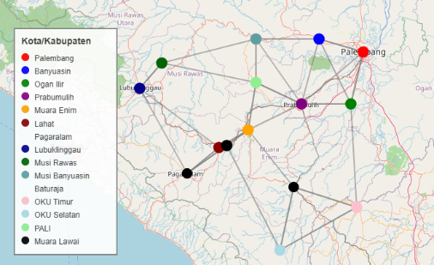
Figure 1. Spatial Distribution of Medical Device Demand South Sumatera Region.

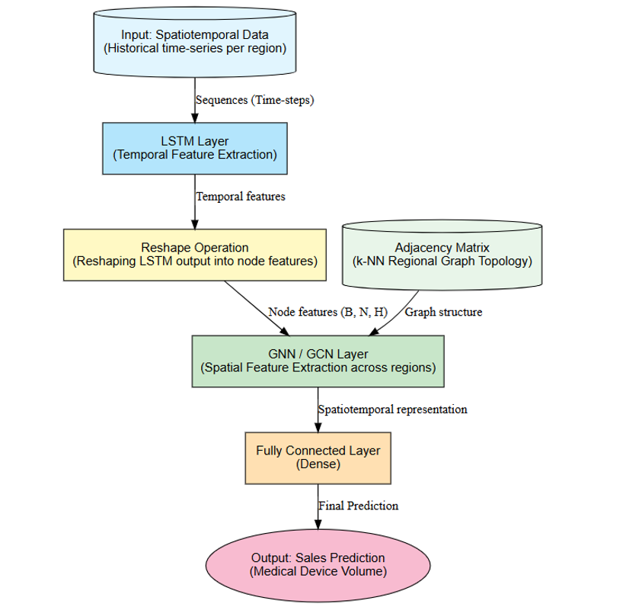
Figure 2. Adjusted Hybrid LSTM-GNN Architecture.
Data preprocessing was performed to improve data quality and ensure compatibility with deep learning models. First, incomplete and duplicated records were removed. Temporal ordering was ensured by sorting all transactions chronologically. Since the distribution of sales values exhibited significant skewness, a Power Transformer was applied to normalize the target variable. This transformation stabilizes variance and improves model convergence during training. To model temporal dependencies, the preprocessed data were converted into a supervised learning format using a sliding window approach with a window size of 60 time steps.
The Long Short-Term Memory (LSTM) network uses special gates to process historical sales sequences for each region. At each time step $t$, the LSTM updates its hidden state using the input vector $x_{t}$ (historical sales data) with the following core equations:

Forget Gate ($f_{t}$): Determines what information to throw away from the cell state.

$$f_{t}= σ(W_{f} . \left[h_{t-1}, x_{t}\right]+ b_{t})$$

Input Gate ($i_{t})$: Determines which new information we’re going to store in the cell state.

$$i_{t}= σ(W_{i} . \left[h_{t-1}, x_{t}\right]+ b_{i})$$

To capture spatial dependencies between regions, a graph-based representation was constructed where each node represents a city or regency, and edges represent spatial relationships. An adaptive k-nearest neighbor method was employed, connecting each region to its three nearest neighbors based on Euclidean distance, with a maximum distance threshold of 95.82 km to prevent unrealistic long-distance connections. The resulting adjacency matrix represents the spatial structure of the study area and is used as input to the Graph Neural Network component.
The proposed model integrates an LSTM network and a GNN into a unified hybrid framework, consisting of a temporal modeling module, a spatial modeling module, and a fusion module presented in Figure 2. The temporal module uses an LSTM network to model historical sales sequences and produce temporal feature representations. The spatial module employs a Graph Attention Network (GAT) to learn spatial representations from the constructed regional graph, assigning different weights to neighboring nodes. The fusion module combines the temporal and spatial representations using an attention-based fusion layer to dynamically weight their contributions before generating the final prediction through a fully connected layer. Hyperparameter optimization was conducted using random search, and the model was trained using the Adam optimizer with mean squared error as the loss function (Pratama, Setiawan, & Purnamasari, 2025). Performance was evaluated using Mean Absolute Error (MAE), Root Mean Squared Error (RMSE), Mean Absolute Percentage Error (MAPE), and the coefficient of determination (R-squared).

RESULT
The experiments were conducted using the preprocessed spatio-temporal dataset, divided into training, validation, and testing sets following a chronological split to preserve temporal consistency. Four models were evaluated: a standalone LSTM model, a standalone GNN model, the proposed Hybrid LSTM-GNN model and Hybrid LSTM-GNN Tuned. All models presented in Table2 and Figure 3 were trained using the same dataset and evaluated using identical metrics to ensure a fair comparison.
Table 2. summarizes the performance comparison of the evaluated models.
Model | RMSE | MAE | MAPE (%) | R²
Standalone LSTM | 0.1523 | 0.1426 | 22.301 | 0.5306
Standalone GNN | 0.2604 | 0.2242 | 51.123 | 0.0804
Hybrid LSTM-GNN | 0.1252 | 0.1273 | 19.911 | 0.6452
Hybrid LSTM-GNN Tuned | 0.0881 | 0.0324 | 8.219 | 0.8595
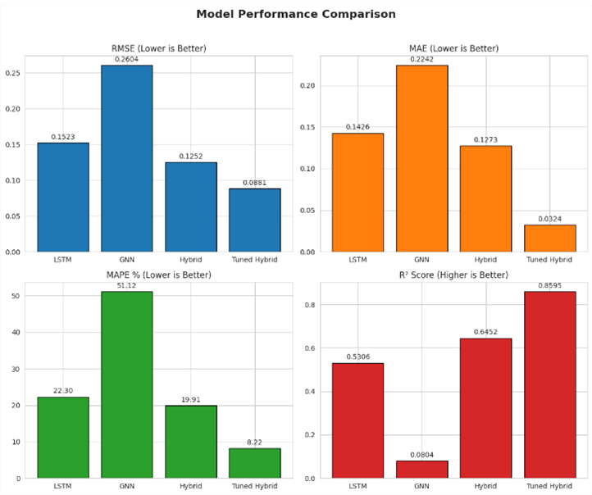
Figure 3. Model Performance Comparison.
The standalone LSTM model demonstrates reasonable performance in modeling temporal trends, achieving an RMSE of 0.1523. However, its inability to incorporate spatial dependencies results in higher prediction errors for regions whose demand is influenced by neighboring areas. The standalone GNN model produces weaker performance, with an RMSE of 0.2604, indicating that spatial information alone is insufficient to accurately model the temporal evolution of medical device sales. In contrast, the proposed Hybrid LSTM-GNN Tuned model achieves the best performance across all metrics, with an RMSE of 0.0881, MAE of 0.0324, MAPE of 8.219%, and an R-squared score of 0.8595.
The impact of hyperparameter optimization on model performance is presented in Table 3 and Figure 4. The default Hybrid LSTM-GNN configuration yielded an MAE of 0.1273 and an RMSE of 0.1252. After applying random search-based hyperparameter optimization, the model showed substantial improvements.
Table 3. The default Hybrid LSTM-GNN configuration
Test | LSTM Units | Spatial Dense Units | Learning Rate | Batch Size | MAE | RMSE | MAPE (%) | R²
1 | 32 | 16 | 0.001 | 32 | 0.1273 | 0.1252 | 19.90 | 0.6452
2 | 32 | 32 | 0.001 | 64 | 0.0984 | 0.1027 | 14.62 | 0.7421
3 | 64 | 32 | 0.0005 | 32 | 0.0762 | 0.0945 | 11.83 | 0.8014
4 | 64 | 64 | 0.0005 | 64 | 0.0526 | 0.0897 | 9.47 | 0.8346
5 | 64 | 64 | 0.0003 | 32 | 0.0324 | 0.0881 | 8.219 | 0.8595

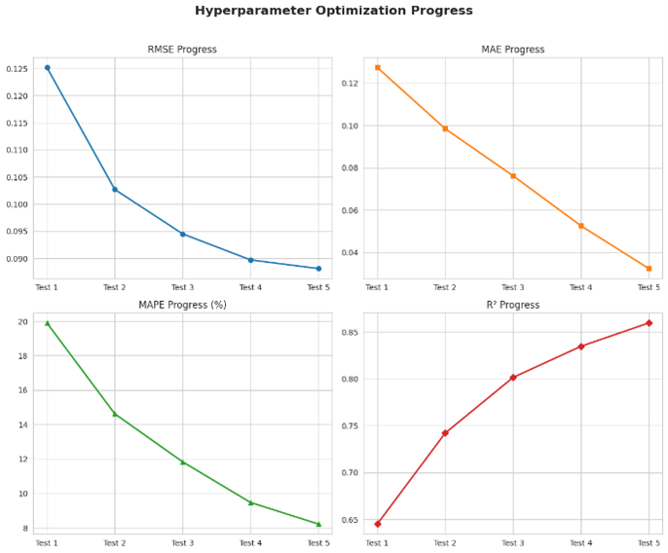
Figure 4. Hyperparameter Optimization Progress

DISCUSSIONS
The experimental results demonstrate that the proposed Hybrid LSTM-GNN model achieves substantially better prediction performance compared to standalone LSTM and GNN models. The hybrid model records the lowest MAE, RMSE, and MAPE values, as well as the highest R-squared score, confirming that integrating temporal and spatial information enables the model to capture more comprehensive demand patterns. The superior performance of the hybrid model can be attributed to its ability to model both long-term temporal dependencies through the LSTM component and inter-regional spatial correlations through the Graph Neural Network.
The impact of spatial dependencies is particularly evident in regions with geographically close neighbors and similar healthcare demand characteristics. The inclusion of spatial information reduces prediction errors in regions where demand fluctuations are influenced by neighboring areas. This finding aligns with the first law of geography, stating that near things are more related than distant things. By constructing a spatial graph using adaptive k-nearest neighbors, the model effectively propagates demand information between connected regions, allowing the hybrid model to adjust predictions dynamically based on spatial context. Furthermore, residual analysis of the hybrid model shows that prediction errors are symmetrically distributed around zero, indicating the absence of systematic bias. This stability suggests that the hybrid model is more robust in handling demand volatility, which is critical for real-world applications where medical device demand may change rapidly due to emergencies or policy interventions.
From a practical perspective, the findings of this study provide important implications for healthcare supply chain management. Accurate spatio-temporal demand forecasting enables distributors and policymakers to anticipate regional demand more effectively, reduce stock shortages, and optimize distribution routes. Despite its strong performance, this study has limitations. The model relies primarily on historical sales data and geographical proximity, without incorporating external factors such as population demographics, disease outbreaks, or economic indicators. Additionally, the experiments were conducted in an offline setting, and real-time deployment was not evaluated.

CONCLUSION
This study proposed a Hybrid Long Short-Term Memory and Graph Neural Network (LSTM-GNN) model for spatio-temporal prediction of regional medical device sales. The proposed approach was designed to jointly capture temporal sales dynamics and spatial dependencies between regions, addressing the limitations of traditional time-series models that consider temporal information alone. Experimental results demonstrate that the Hybrid LSTM-GNN model significantly outperforms standalone LSTM and GNN models across all evaluation metrics. The optimized hybrid model achieved an RMSE of 0.0881, an MAE of 0.0324, a MAPE of 8.219%, and an R-squared score of 0.8595. These results confirm that incorporating spatial relationships through graph-based learning substantially improves forecasting accuracy, particularly in regions with strong inter-regional demand interactions. The findings also highlight the importance of hyperparameter optimization in hybrid deep learning architectures. From a practical perspective, the proposed model provides valuable support for medical device distribution planning and healthcare supply chain management. Future research may extend this work by integrating external variables, exploring dynamic spatial graphs, and implementing the proposed model in real-time decision support systems.

ACKNOWLEDGMENT (optional)
The author would like to express sincere gratitude to the academic supervisors for their guidance and constructive feedback throughout the completion of this research. Appreciation is also extended to the medical device distribution company for providing access to sales transaction data used in this study. The author gratefully acknowledges the support of the Faculty of Computer and Natural Sciences, Universitas Indo Global Mandiri, for facilitating the research process and providing an academic environment conducive to this study.

REFERENCES

Alourani, A., Khan, N. A., Ashfaq, F., & Jhanjhi, N. Z. (2023). BiLSTM‐and GNN‐Based Spatiotemporal Traffic Flow Forecasting with Correlated Weather Data. Journal of Advanced Transporation. https://doi.org/10.1155/2023/8962283
Beldek, T., Konyalıoğlu, A., & Camgoz Akdag, H. (2019). Supply Chain Management in Healthcare: A Literature Review. https://doi.org/10.1007/978-3-030-31343-2_50
Chen, W., Zhao, Z., Liu, J., Chen, P. C. Y., & Wu, X. (2017). LSTM Network: A Deep Learning Approach For Short-Term Traffic Forecast. IET Intelligent Transport Systems, 11. https://doi.org/10.1049/iet-its.2016.0208
Cheng, Michael. (2003). Medical device regulations : global overview and guiding principles. World Health Organization.
Heryati, A., Stiawan, D., Setiawan, H., Rini, D. P., & Budiarto, R. (2024). Green Transportation Route Model for Industrial Goods Delivery with Genetic Algorithm. 2024 11th International Conference on Electrical Engineering, Computer Science and Informatics (EECSI), 775–781. https://doi.org/10.1109/EECSI63442.2024.10776095
Hochreiter, S., & Schmidhuber, J. (1997). Long Short-Term Memory. Neural Computation, 9, 1735–1780. https://doi.org/10.1162/neco.1997.9.8.1735
Koç, E., & Türkoğlu, M. (2022). Forecasting of medical equipment demand and outbreak spreading based on deep long short-term memory network: the COVID-19 pandemic in Turkey. Signal, Image and Video Processing, 16(3), 613–621. https://doi.org/10.1007/s11760-020-01847-5
Kuppan, K., Acharya, D. B., & B, D. (2024). LSTM-GNN Synergy: A New Frontier in Stock Price Prediction. Journal of Advances in Mathematics and Computer Science, 39(12), 95–109. https://doi.org/10.9734/jamcs/2024/v39i121952
Liu, J., & Liu, J. (2024). Research on Predicting Wind Turbine Power Generation based on Hybrid LSTM-GNN Model. International Core Journal of Engineering. Retrieved from https://www.airitilibrary.com/Article/Detail/P20190813001-N202411300006-00008
Longa, A., Lachi, V., Santin, G., Bianchini, M., Lepri, B., Lio, P., … Passerini, A. (2023). Graph Neural Networks for temporal graphs: State of the art, open challenges, and opportunities.
Luo, M., Dou, H., & Zheng, N. (2024). Spatiotemporal Prediction of Urban Traffics Based on Deep GNN. Computers, Materials &Continua. Retrieved from https://search.ebscohost.com/login.aspx?direct=true&profile=ehost&scope=site&authtype=crawler&jrnl=15462218&AN=175291515&h=qgjot5heXUUNvFKaEFDSunG1q3%2FBgMKOK1Drwik7yg24rjme0mlR2dWT0Ky7R1OoWZ0vnOTNwLcTKXU45tRj4A%3D%3D&crl=c
Patharkar, A., Cai, F., Al-Hindawi, F., & Wu, T. (2024). Predictive modeling of biomedical temporal data in healthcare applications: review and future directions. Frontiers in Physiology, Vol. 15. Frontiers Media SA. https://doi.org/10.3389/fphys.2024.1386760
Pratama, M. A. Y., Setiawan, H., & Purnamasari, E. (2025). CNN-Based Identification of Longan Varieties Using Leaf Vein Patterns. Brilliance: Research of Artificial Intelligence, 5(2), 870–878. https://doi.org/10.47709/brilliance.v5i2.6926
Santos, V. O., Rocha, P. A. C., Scott, J., Thé, J. V. G., & Gharabaghi, B. (2023). Spatiotemporal analysis of bidimensional wind speed forecasting: Development and thorough assessment of LSTM and ensemble graph neural networks on the Dutch database. Energy. Retrieved from https://www.sciencedirect.com/science/article/pii/S036054422301246X
Shao, C., Pan, J., Wei, Y., Zhang, W., & Lin, Z. (2023). Fault Prognostics of Elevator Door System Based on LSTM-GNN. Global Reliability and Prognostics and Health Management Conference (PHM-Hangzhou). Retrieved from https://ieeexplore.ieee.org/abstract/document/10482723/
Sonani, M. S., Badii, A., & Moin, A. (2025). Stock Price Prediction Using a Hybrid LSTM-GNN Model: Integrating Time-Series and Graph-Based Analysis.
Sunder, R., Paul, V., Punia, S. K., Konduri, B., Nabilal, K. V, Lilhore, U. K., … Tlija, M. (2024). An advanced hybrid deep learning model for accurate energy load prediction in smart building. Energy Exploration & Exploitation. https://doi.org/10.1177/01445987241267822
Tunnicliffe Wilson, G. (2016). Time Series Analysis: Forecasting and Control,5th Edition, by George E. P. Box, Gwilym M. Jenkins, Gregory C. Reinsel and Greta M. Ljung, 2015. Published by John Wiley and Sons Inc., Hoboken, New Jersey, pp. 712. ISBN: 978-1-118-67502-1. Journal of Time Series Analysis, 37, n/a-n/a. https://doi.org/10.1111/jtsa.12194
Veličković, P., Casanova, A., Liò, P., Cucurull, G., Romero, A., & Bengio, Y. (2018). Graph attention networks. 6th International Conference on Learning Representations, ICLR 2018 - Conference Track Proceedings. International Conference on Learning Representations, ICLR. https://doi.org/10.1007/978-3-031-01587-8_7
Wen, Z., Zhou, H., Shi, X., Peng, J., & Wang, L. (2024). LSTM-GNN: A Multi-Channel Model for Molecular Properties Prediction. Proceedings of the 2024 16th International Conference on Bioinformatics and Biomedical Technology. https://doi.org/10.1145/3674658.3674677
World Health Organization. (2023). Model List of Essential Medicines. In 23rd List: Vol. 23rd. https://www.who.int/publications/i/item/WHO-MHP-HPS-EML-2023.02. Retrieved from https://www.who.int/publications/i/item/WHO-MHP-HPS-EML-2023.02
Wu, Z., Pan, S., Long, G., Jiang, J., & Zhang, C. (2019). Graph wavenet for deep spatial-temporal graph modeling. IJCAI International Joint Conference on Artificial Intelligence, 2019-August, 1907–1913. International Joint Conferences on Artificial Intelligence. https://doi.org/10.24963/ijcai.2019/264
Xu, K., Hu, W., Leskovec, J., & Jegelka, S. (2018). How powerful are graph neural networks? ArXiv Preprint ArXiv:1810.00826.
Yang, Y., Liu, Y., Zhang, Y., Shu, S., & Zheng, J. (2025). DEST-GNN: A double-explored spatio-temporal graph neural network for multi-site intra-hour PV power forecasting. Applied Energy. Retrieved from https://www.sciencedirect.com/science/article/pii/S0306261924021275
Yang, Z., Liu, Z., Zhou, J., Song, C., Xiang, Q., He, Q., … Zhang, J. (2023). A graph neural network (GNN) method for assigning gas calorific values to natural gas pipeline networks. Energy. Retrieved from https://www.sciencedirect.com/science/article/pii/S0360544223012690
Ye, Y., Cao, Y., Dong, Y., & Yan, H. (2024). A Graph Neural Network and Transformer-Based Model for Pm2.5 Prediction Through Spatiotemporal Correlation. https://doi.org/10.2139/ssrn.4979506
Zhao, Y., Qi, J., Liu, Q., & Zhang, R. (2021). WGCN: graph convolutional networks with weighted structural features. Proceedings of the 44th International ACM SIGIR Conference on Research and Development in Information Retrieval, 624–633.

